  - Create a Transparent Image Text


  - Create a Form on Image


  - Create a Side Navigation Buttons
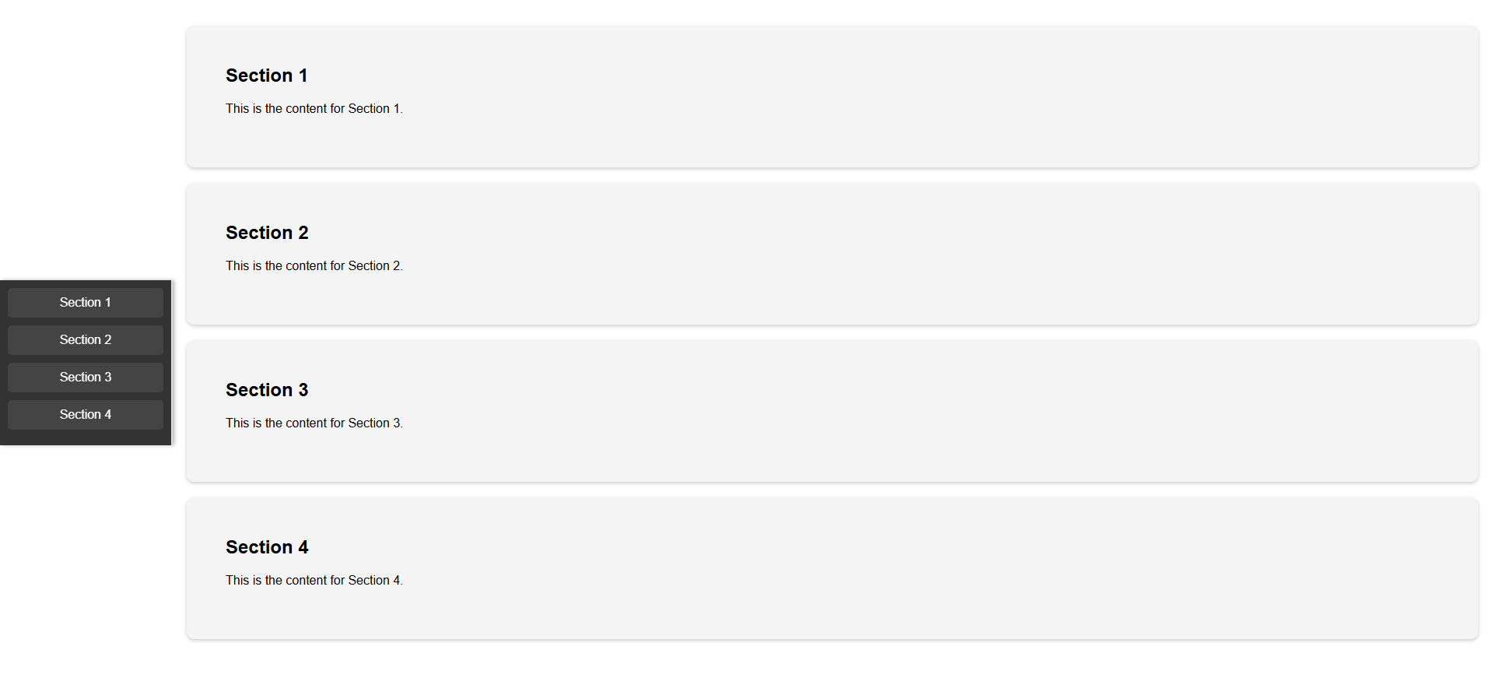
  - Create Automatic Slideshow
Slide 1
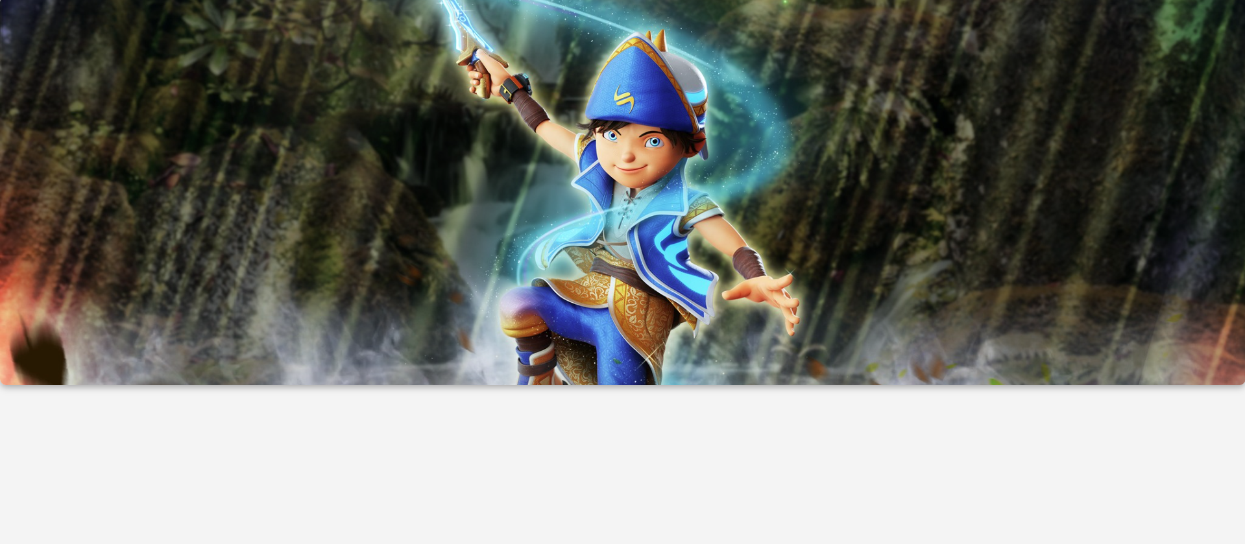
Slide 2
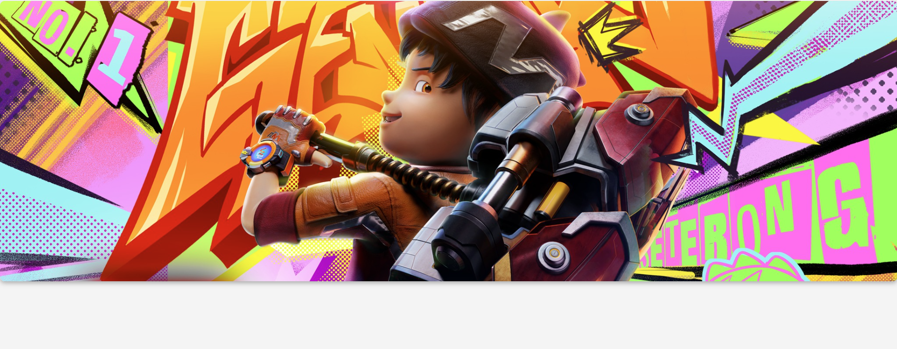

Slide 3
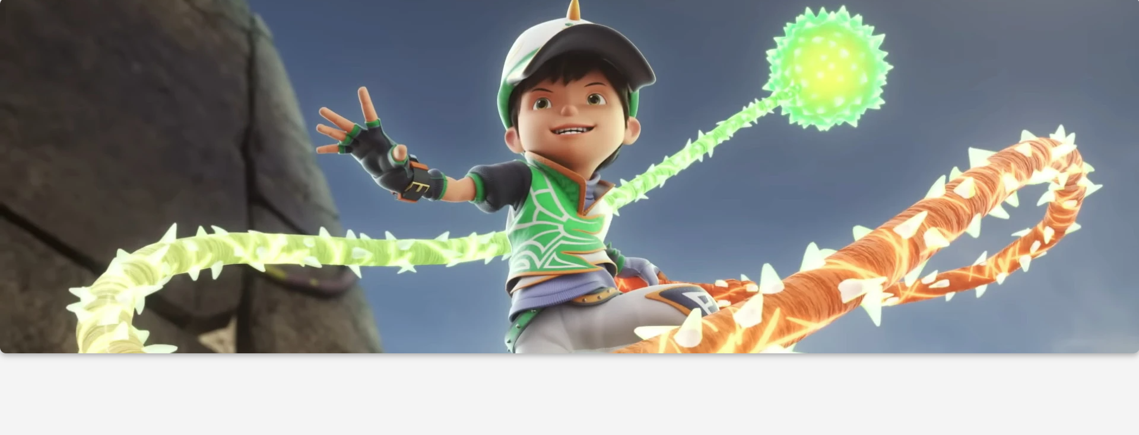
  - Create Profile Card
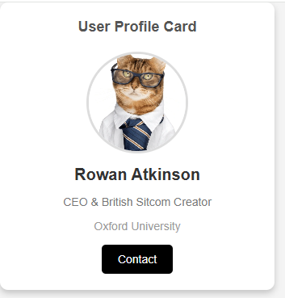
  - Create Progress Bar
When I press the “Increase Progress” button:


When the progress bar is full:

When I press the “reset” button:

  - Create A Collapsible
When I press the “Click to Expand/Collapse” button:
